**Internet Explorer 10 and 11**

By default **Internet Explorer 10** does not run in compatibility mode. This is easily tested by logging into **MIG-MIS** and logging in , you will notice that the content tree is not functioning.. If the compatibility mode is not enabled, some functionality in MIG-MIS will not work

To enable the compatibility mode for **Internet Explorer 10,** follow these steps:

**For Windows 7 users start at step 2.**

1. **Windows 8 only** - From the **Windows 8** start screen select the **Desktop**.  
     
   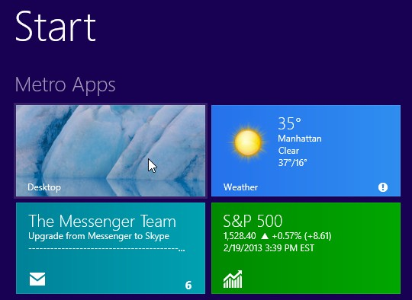
2. From the **Desktop** launch **Internet Explorer 10**.  
     
   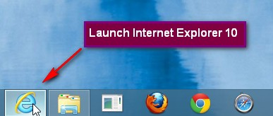
3. Press the **Alt** key on your keyboard to bring up the top menu.
4. Go to **Tools | Compatibility View** settings  
     
   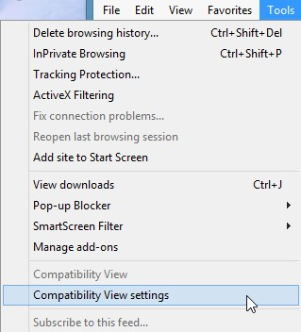
5. Either
   * Add http://**mig.dplg.gov.za or Http://mig.cogta.gov.za** to the **Compatibility View** websites  
     or
   * Select **Display all websites in Compatibility View  
       
     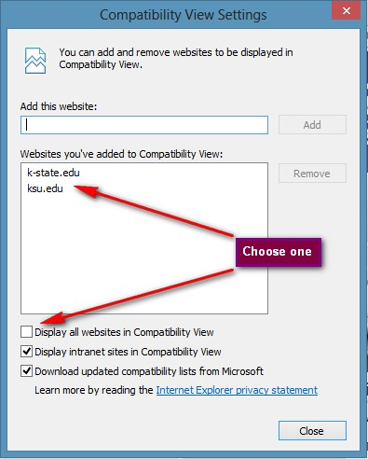**

Add the website and select the display all websites in compatibility mode box

1. **NOTE**: enabling the compatibility mode using either option will ***affect*** all **mig.cogta.gov.za or mig.dplg.gov.za** web sites.